**Introduction**

The Friedman test is the non-parametric alternative to the one-way ANOVA with repeated measures. It is used to test for differences between groups when the dependent variable being measured is ordinal 1.

**Assumptions**

1. One group that is measured on three or more different occasions 1.
2. Group is a random sample from the population 1.
3. Your dependent variable should be measured at the ordinal or continuous level 1.

**Difference to ANOVA (procedure)**

1. Samples doesn’t have to be normally distributed 2.
2. There doesn't need to be homogeneity of variances 2.

**Procedure**

1. Rank the values in each row from low to high 4.
2. Sum the ranks in each column 4.
3. Calculate the test statistic as follows 2:

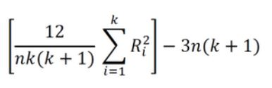

Finally, when n or k is large (i.e. n > 15 or k > 4), the probability distribution of Q can be approximated by that of a chi-squared distribution 3.

**Examples**

1. n wine judges each rate k different wines. Are any of the k wines ranked consistently higher or lower than the others 3?
2. n welders each use k welding torches, and the ensuing welds were rated on quality. Do any of the k torches produce consistently better or worse welds 3?

References:

1. <https://statistics.laerd.com/spss-tutorials/friedman-test-using-spss-statistics.php>
2. Nadari, B. (2020). *Quality and usability (statistics).* Seminar. TU-Berlin. 04. February 2020
3. <https://en.wikipedia.org/wiki/Friedman_test>
4. www.graphpad.com › prism › statistics › how_the_friedman_test_works